II.2317 Cybersecurity (ISEP)

LAB Blockchain (Proof-of-Work)

Part I: Understanding the Bitcoin Header…………2

Part 2: Implementation of a PoW…………………4

GUO Xiaofan

ZHAO Chao

## Part I: Understanding the Bitcoin Header

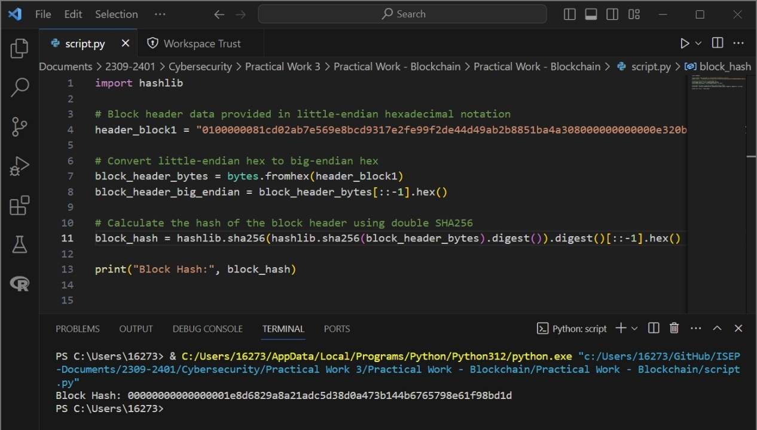

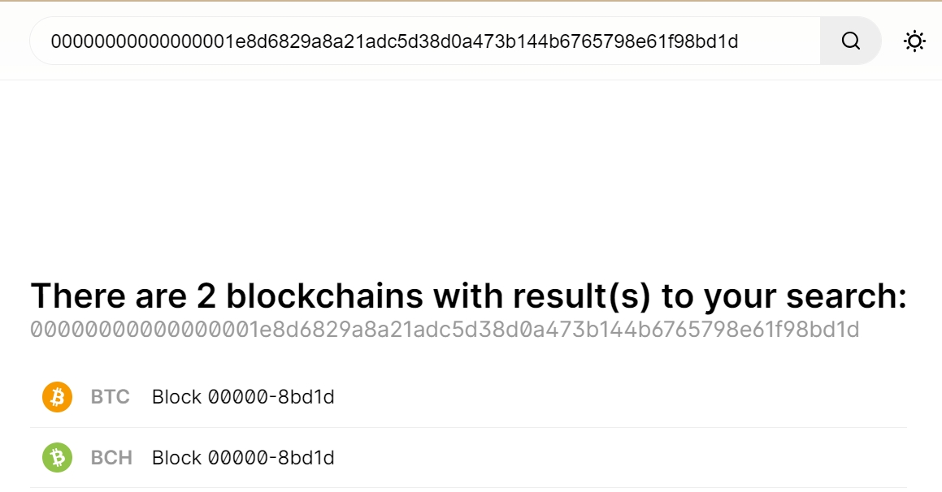

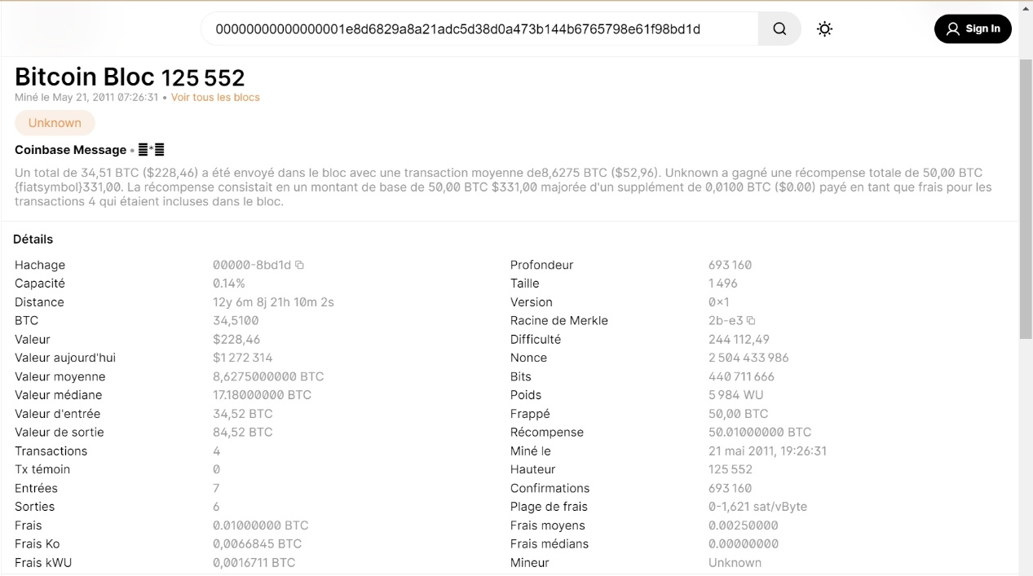

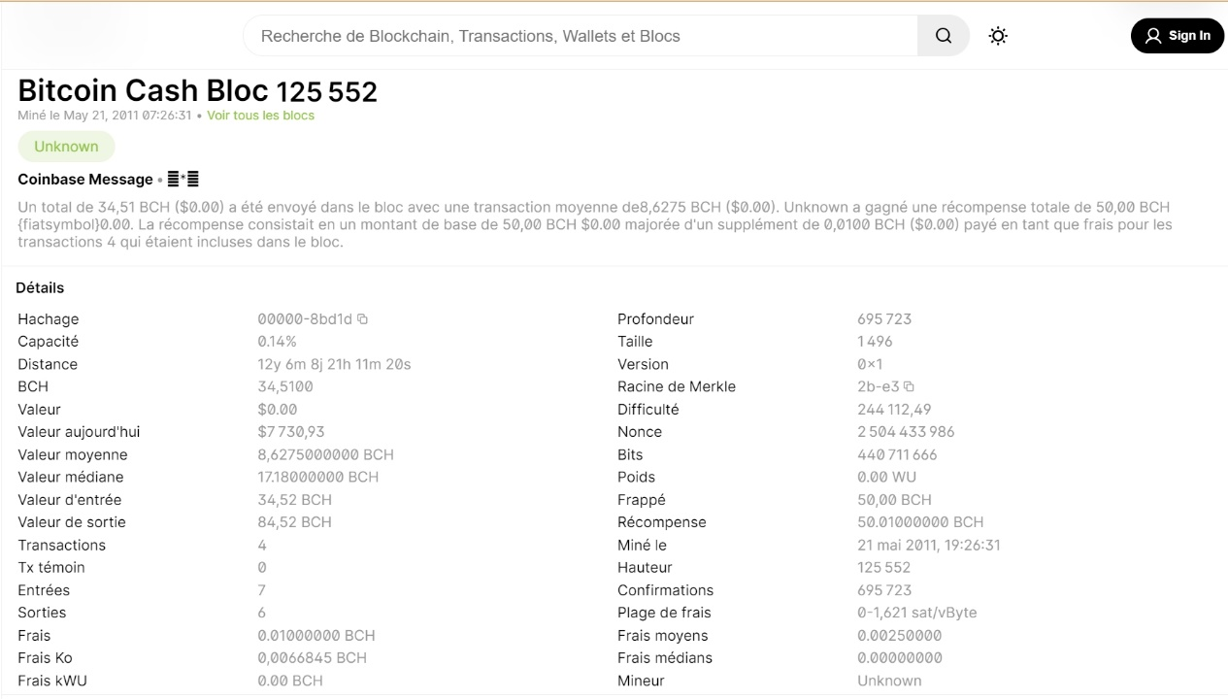

**block mined:** 21 may 2011, 19:26:31

**the number of confirmations:** 695 723

## Part 2: Implementation of a PoW

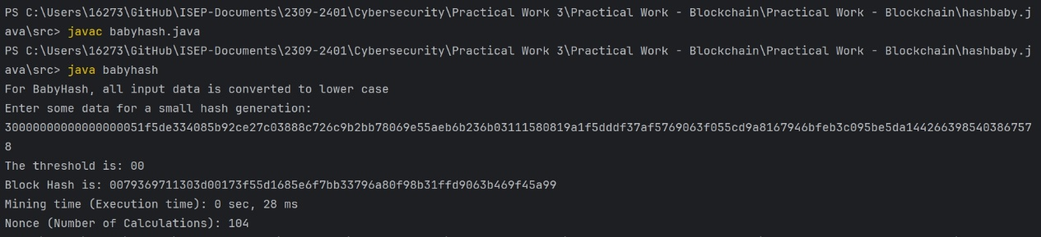

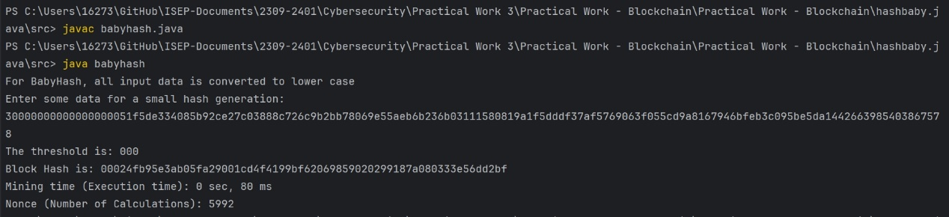

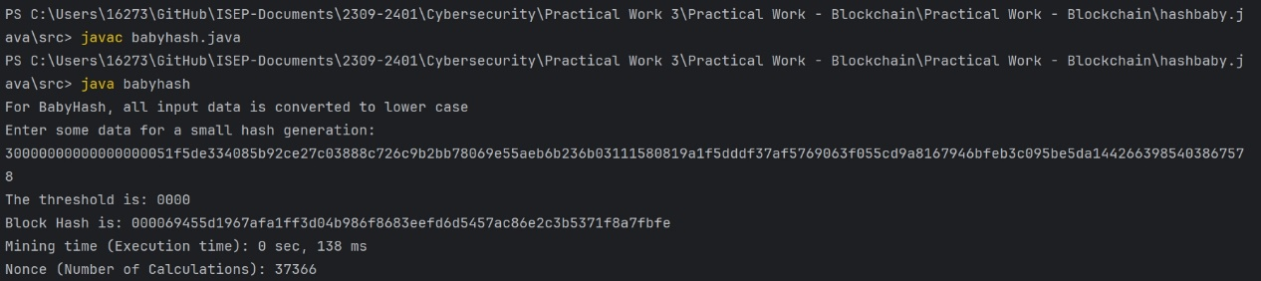

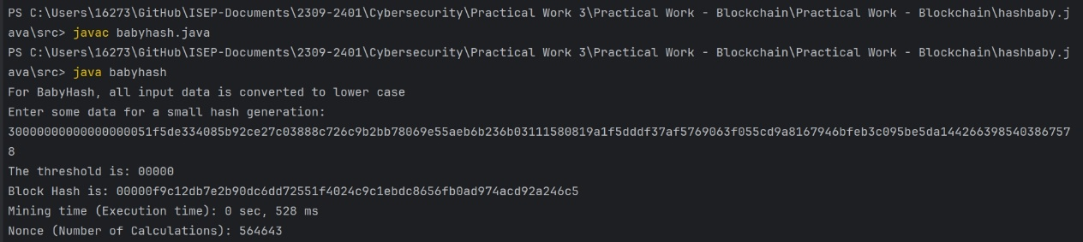

|  |  |  |
| --- | --- | --- |
| Number of Zeros | Execution Time | Number of calculations |
| 00 | 28ms | 104 |
| 000 | 80ms | 5992 |
| 0000 | 138ms | 37366 |
| 00000 | 528ms | 564643 |